**Implementation of Autonomous Micro-Drone System for Public Security and Surveillance**

OF PROJECT

**BACHELOR OF TECHNOLOGY**

**Electronics & Communication Engineering**

Batch: 2022-26

**SUBMITTED BY:**

ANMOL KUMAR SRIVASTAV, MANI RAJ, AMAN BHARTI, SUDHA JAISWAL, DEVVRAT

**March- June, 2025**

**Supervisors:**

**DR. MUNISH RATTAN**

**DR. GURPURNEET KAUR**



**GURU NANAK DEV ENGINEERING COLLEGE, LUDHIANA**

**Title of Project**:   
**Implementation of Autonomous Micro-Drone System for Public Security and Surveillance**

**Introduction:**

Drones are revolutionizing industries with their advanced capabilities in aerial photography, surveillance, mapping, agriculture, and disaster response. They enable real-time data collection, enhance security operations, assist in search and rescue missions, and optimize farming with precision monitoring. Additionally, drones are widely used in construction for site inspections, in logistics for deliveries, and in environmental conservation for wildlife tracking and monitoring climate changes. Their versatility also extends to recreational activities, including racing and FPV flying, making them an essential tool for both professionals and enthusiasts. Fig. 1 outlines the block diagram of Autonomous Micro-Drone System

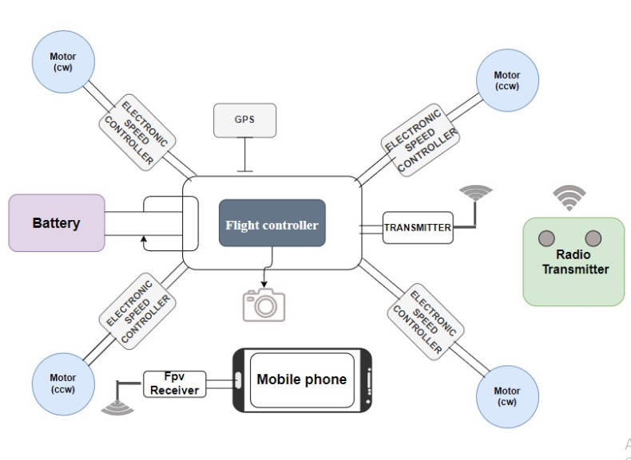

**Fig.1. Block diagram of Autonomous Micro-Drone System**

**Objectives**:

* To design and implement an autonomous micro-drone system for public security and surveillance.
* Testing of developed drone.

**Novelty/Innovation**:

An autonomous drone system will be developed that will have the following features.

1. **Micro Drone Design** – Compact and lightweight for enhanced agility and easy deployment.
2. **Security and Surveillance** – Designed for public security applications, ensuring effective monitoring and threat detection.
3. **Automated Return-to-Home (RTH) Functionality** – Automatically returns to its launch point when battery power is critically low, ensuring safety and uninterrupted operation
4. **Integrated Camera System** – Equipped with a **high-resolution camera** for **real-time video streaming, surveillance, and data collection**.
5. **GPS Tracking & Navigation** – Integrated GPS module for precise location tracking, autonomous navigation, and real-time monitoring of drone movements.

**Expected Outcomes**: An autonomous drone system will be developed and research work can be presented in reputed conference/Journal.

**Budget Estimate**:

|  |  |  |  |  |
| --- | --- | --- | --- | --- |
| **Equipment name** | **No of piece** | | **Amount ofequipment** | **Total amount** |
| Filament for3D PRINT Quadcopter Drone | 2 | | Rs.1,680.00 | Rs.3,360.00 |
| 2212 920KV CCW Self-Locking Brushless Motor For Drone & RC Plane | 2 | | Rs.665.00 | Rs. 1,330.00 |
| 2212 920KV CW Self-Locking Brushless Motor For Drone & RC Plane | 2 | | Rs. 665.00 | Rs. 1,330.00 |
| 9450 Self Locking Propeller For Drone 1CW+1CCW - (1Pair) - Original | 2 | | Rs. 449.00 | Rs.  898.00 |
| Favorite LittleBee 30A-S OPTO ESC For Drone | 4 | | Rs. 1,366.00 | Rs. 5,464.00 |
| CrossFlight Controller | 1 | | Rs. 4,948.00 | Rs. 4,948.00 |
| Anti-Vibration Shock Absorber for APM PixHawk | 1 | | Rs. 199.00 | Rs. 199.00 |
| NEO 7M GPS With Compass for APM 2.6/2.8 and Pixhawk 2.4.6/2.4.8 | 1 | | Rs. 1,658.00 | Rs. 1,658.00 |
| 3D PRINT GPS Folding Metal Stand For APM & PIXHAWK | 1 | | Rs. 271.00 | Rs. 271.00 |
| XT60 Male Connector With 9cm 14AWG Silicon Wire |  | | Rs.119.00 | Rs.119.00 |
| FS-i6 2.4G 6CH Radio Transmitter With FS-iA6b Receiver (customized) | 1 | | Rs. 4,365.00 | Rs. 4,365.00 |
| 14.8V 4500mAh 4S 35C Lithium Polymer Battery Pack | 1 | | Rs. 4,997.00 | Rs. 4,997.00 |
| 1/3″ CMOS 1500TVL Mini FPV Camera 2.1mm Lens PAL / NTSC With OSD | 1 | | Rs.. 1,269.00 | Rs.1,269.00 |
| 2. EWRF TS5823 600mW Wireless Video Transmitter | 1 | | Rs.1434.00 | Rs.1434.00 |
| 3. 5.8G UVC OTG Android AV Phone Receiver | 1 | | Rs.1434.00 | Rs.1434.00 |
| **Accessories/Tools:**  1. XT60 Male Connector With 9cm 14AWG Silicon Wire  2. 20cm Lipo Battery Strap Belt For Drone  3. 1× 150mm Self Locking Adjustable  Zip Ties (White) 12pcs  4. 1× Allen Key 2mm  5 . 1× Allen Key 2.5mm  6. 1× High-Quality Ultra  Flexible 20AWG Silicone Wire 1m Black  7. 1× Heat Shrink Sleeve 2mm Black 1  8. 25W 230V Soldering Iron (Rajshri).  9.Solder Wire 27gm.  10.Wire Cutter/Stripper 150mm - Taparia. |  | |  | Rs.1000 |
| **Miscellaneous items** |  | |  | Rs.1000 |
| **Total Amount:** | |  |  | **Rs. 34,076/-** | |

**Plan of execution of Work:**

**Month 1:** Preparation, Assembly, and Initial Power Setup

**Month 2:** Design of basic structure of drone and fabrication.

**Month 3:** Remote Control and Basic Flight Setup.

**Month 4:** Autonomous Flight Testing and report writing.

**References:**

1. K.-P. Neitzke, “Rotary Wing Micro Air Vehicle Endurance,” in Proceedings of International Micro Aerial Vehicle Conference and Flight Competition (IMAV). HS.
2. Nordhausen, Institute Informatik, Elektronik, Sep. 2013.
3. [Regulatory Landscape of Indian Drone Ecosystem](https://legalaffairs.gov.in/sites/default/files/Civil%20Aviation%20Regulatory%20Landscape%20of%20Indian%20Drone%20Ecosystem%20red.pdf).
4. https://www.researchgate.net/publication/367196413_The_Application_of_Drone_Technology_for_Sustainable_Agriculture_in_India.
5. <https://www.tec.gov.in/pdf/Studypaper/study_paper_use_cases_of_drones_issued_copy.pd>
6. https://youtu.be/D5Kxp_idoCk?si=XN79q9W9A6hfX_KV.
7. AL-Dosari K, Hunaiti Z, Balachandran W. Drone safety and security surveillance system (d4s). Applied Sciences. 2024 May 15;14(10):4193.
8. Gilani SM, Anjum A, Khan A, Syed MH, Moqurrab SA, Srivastava G. A robust Internet of Drones security surveillance communication network based on IOTA. Internet of Things. 2024 Apr 1;25:101066.
9. Gohari A, Ahmad AB, Rahim RB, Supa’at AS, Abd Razak S, Gismalla MS. Involvement of surveillance drones in smart cities: A systematic review. IEEE Access. 2022 May 25;10:56611-28. Gohari A, Ahmad AB, Rahim RB, Supa’at AS, Abd Razak S, Gismalla MS. Involvement of surveillance drones in smart cities: A systematic review. IEEE Access. 2022 May 25;10:56611-28.

**Name and Signature of Students (University Roll No.)**

1. Anmol Kumar Srivastav (2134680 ), D4ECE

2. Mani Raj (URN: 2203733), D3ECE-A

3.AmanBharti (URN: 2203694), D3ECE-A

4.SudhaJaiswal (URN: 2203766), D3ECE-B

5.Devvrat (URN:2302865) , D2ECE-A

**Name and signature of Supervisor(s)**

1. Dr. Munish Rattan, Associate Professor, ECE Dept.

2. Dr. GurpurneetKaur, Assistant Professor, ECE Dept.